## Jenkins task [Day-01]

**1) Install Jenkins and run Jenkins on port number 8081.**

Installing Jenkins

Running these commands for Jenkins package

* sudo wget -O /etc/yum.repos.d/jenkins.repo https://pkg.jenkins.io/redhat-stable/jenkins.repo
* sudo rpm --import https://pkg.jenkins.io/redhat-stable/jenkins.io-2023.ke

We need some pre requisite Install the JDK for Amazon Corretto 17:

* “sudo yum install java-17-amazon-corretto-devel” (from official aws doc)
* yum install Jenkins

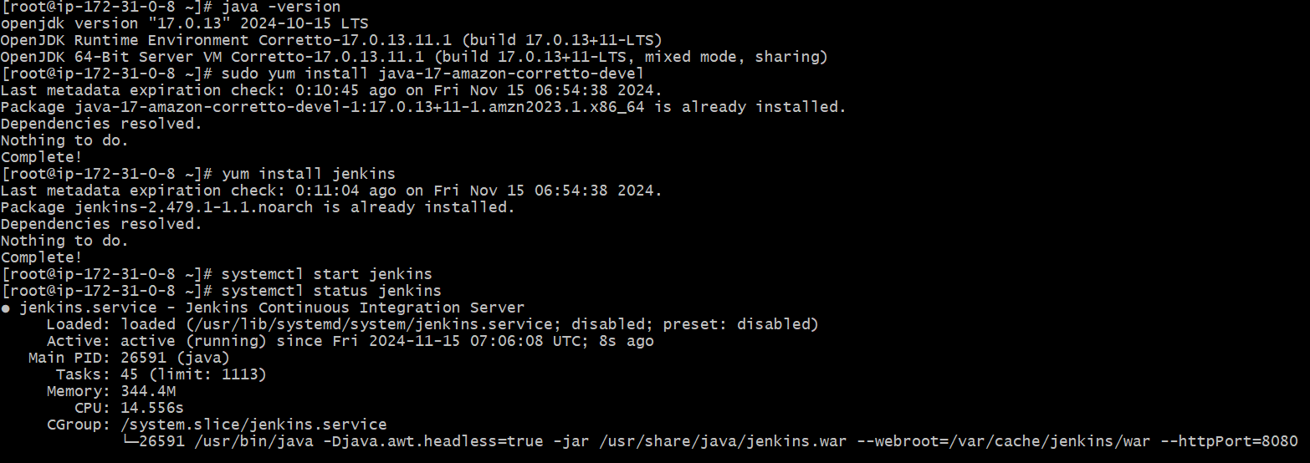

Publicip:8080[we can see the jenkins page]

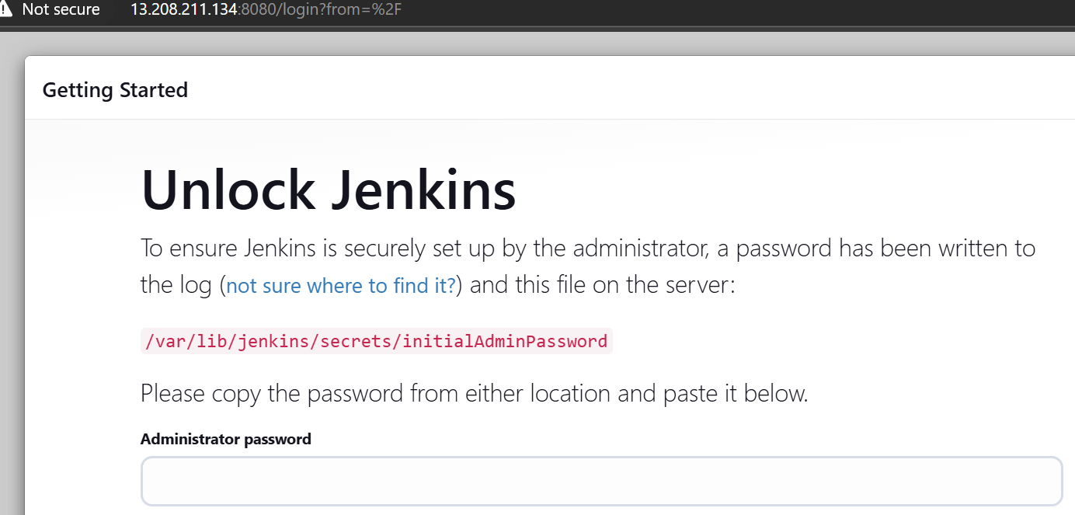

**Running Jenkins on port number 8081.**



To edit the port the service file is

/lib/systemd/system/jenkins.service

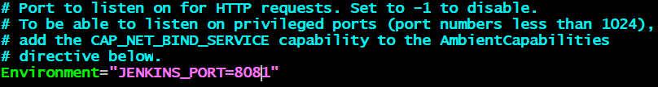

After changing the port ,restart the jenkins

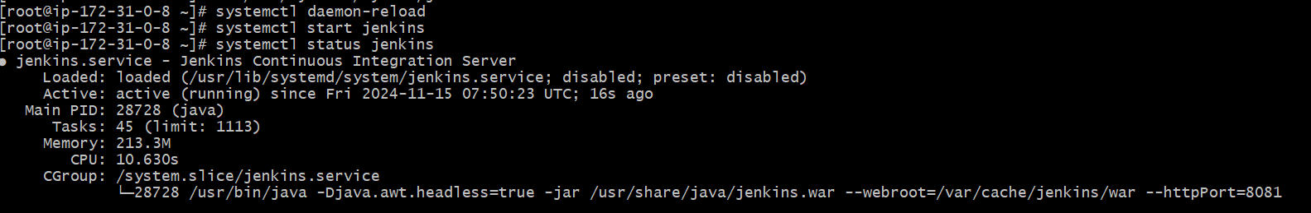

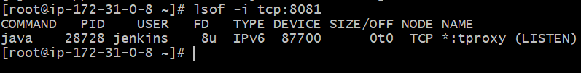

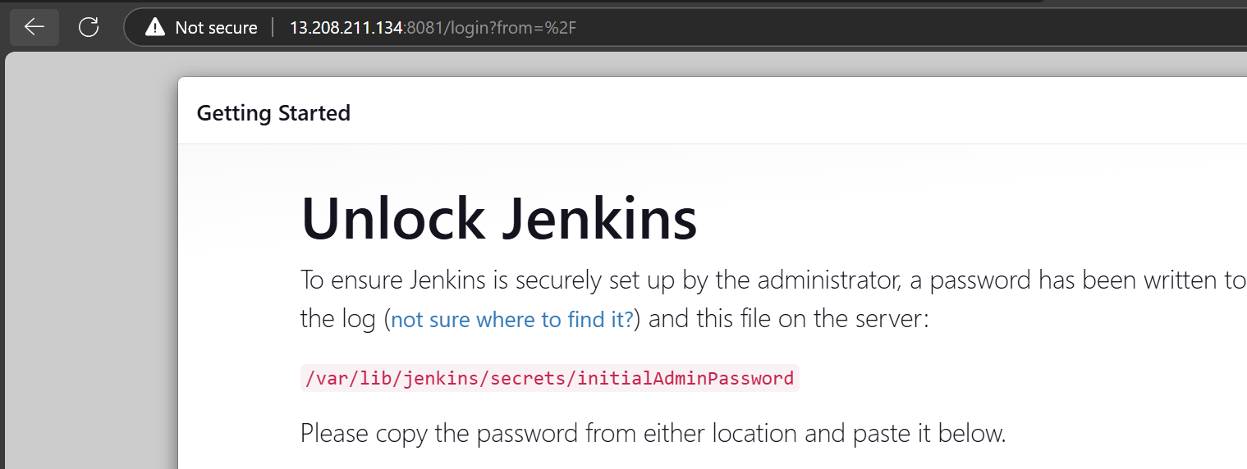

We can check in the browser

**2) Secure Jenkins server**

**To unlock the password**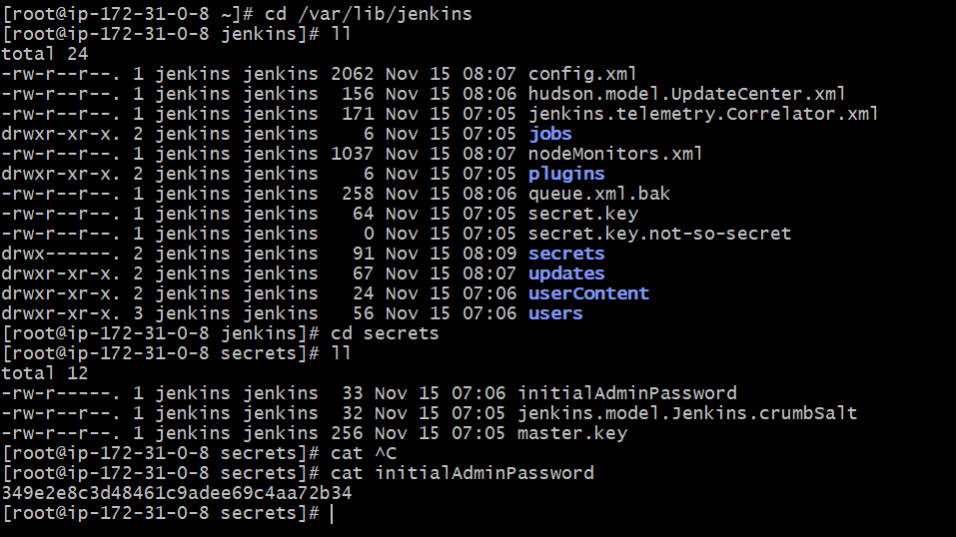

Login to the admin user with suggested plugins

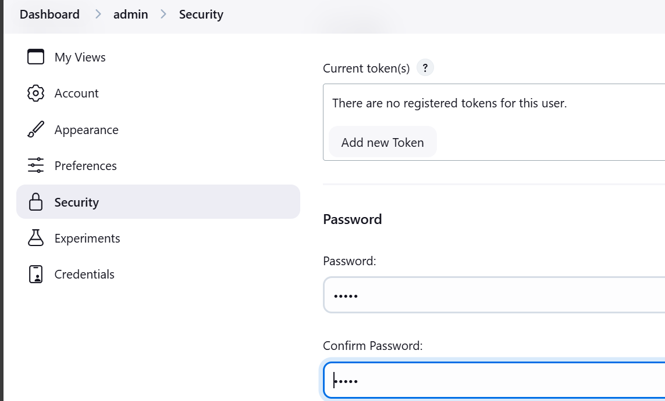

Save the changes

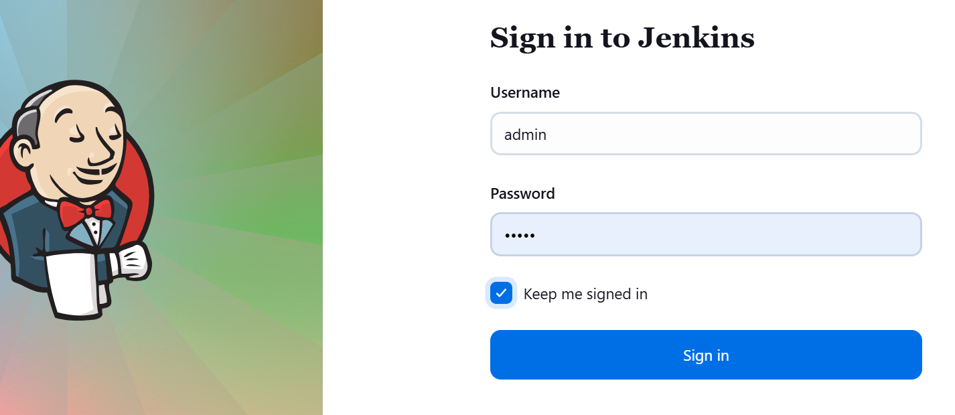

We can able login with new password

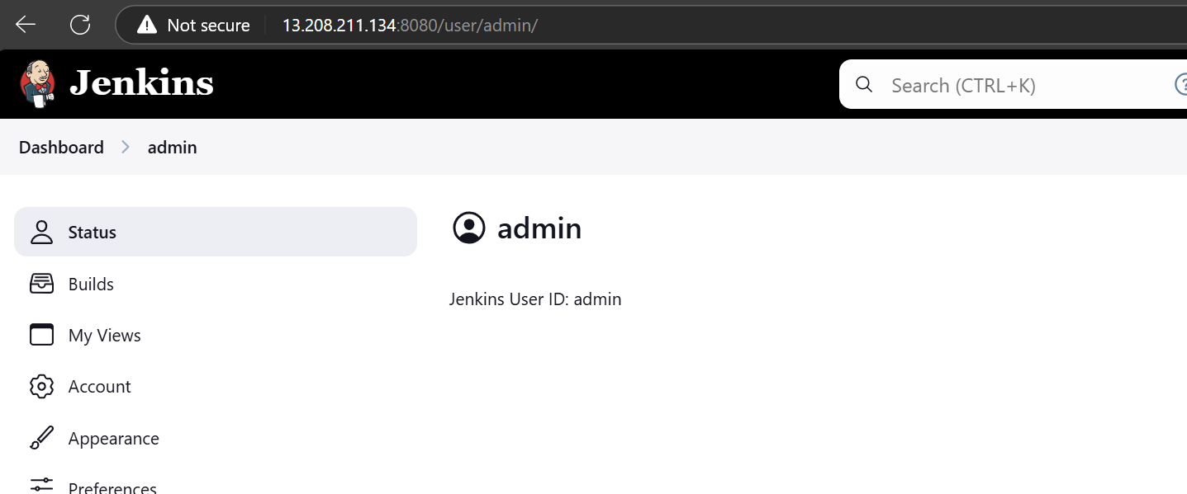

**3) Create users called DevOps, Testing in Jenkins with Limited access.**

To create a user,

* We need to add a plugin

Dashboard>manage Jenkins>plugins>role based authorization

Next for Limited access

Dashboard>Manage Jenkins>Security

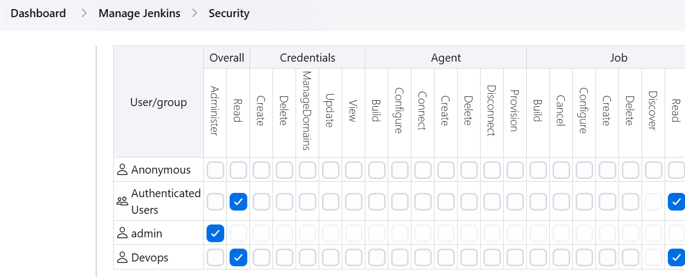

Next,For creating role

Dashboard>manage Jenkins>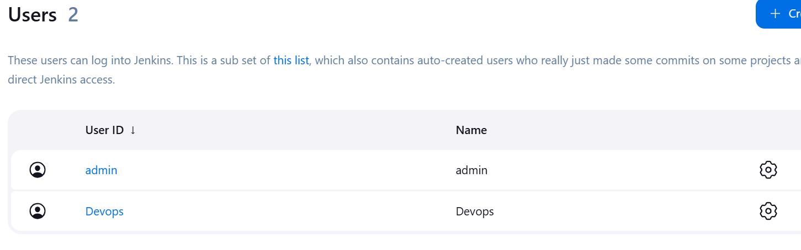

We can check that Devops user has limited access

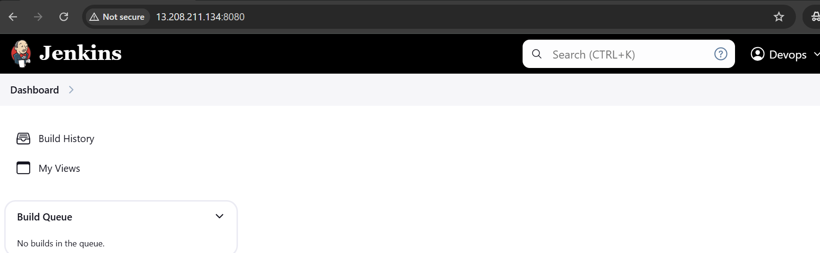

**4) Configure labels and restrict the jobs to execute based on label only.**

Creating two jobs with default settings

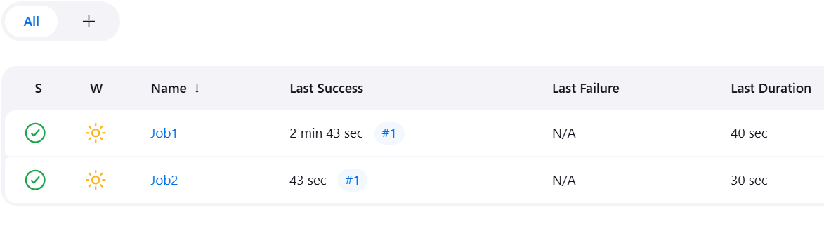

Now go to the Manage Jenkins>system>edit the labels

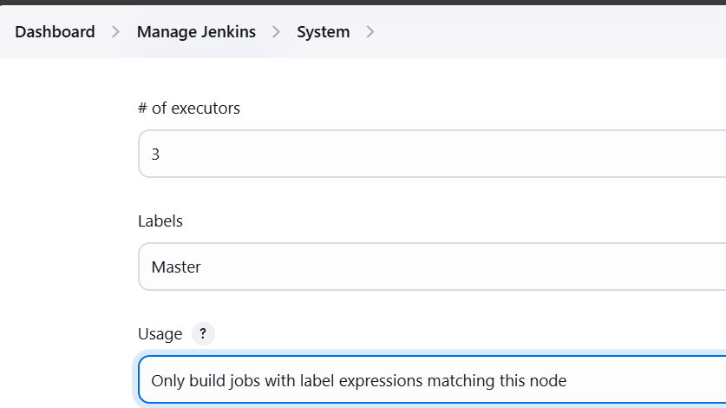

Now try to execute jobs”build now”

We can see that jobs are in queque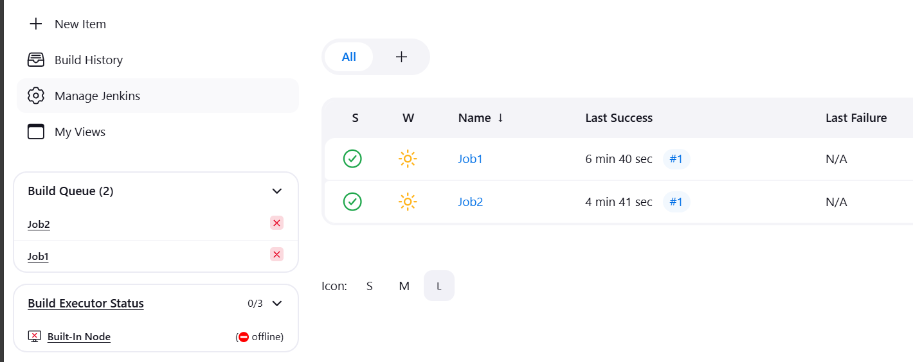

Now if we give that Job1 as master

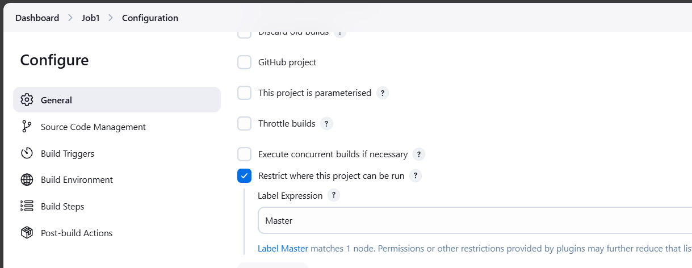

We can see job will run,but job2 will be in queque

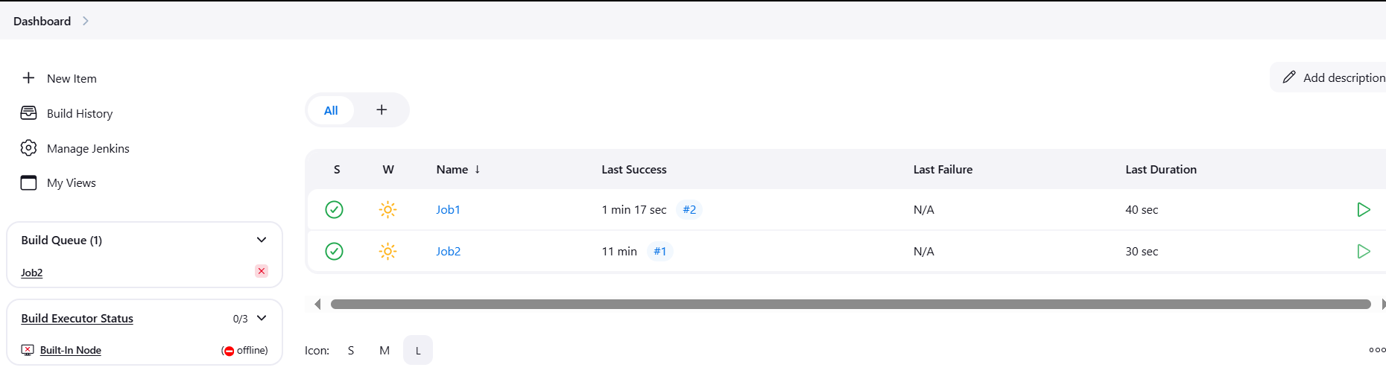

**5) Create Three sample jobs using the below URL.**

[**https://github.com/betawins/Techie_horizon_Login_app.git**](https://github.com/betawins/Techie_horizon_Login_app.git)

create a job in Jenkins with git url attached[we need to install git as we are working with it]

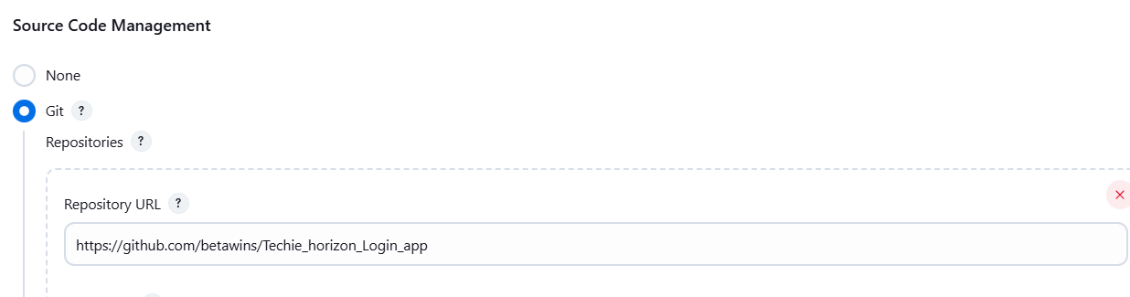

Execute the job ,using build now

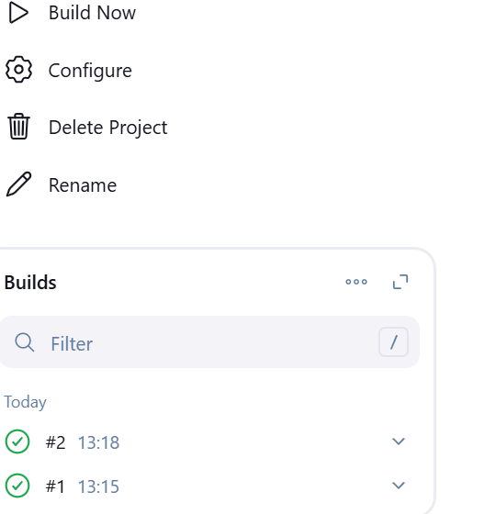

After successful execution of a job we can see that workspace that created 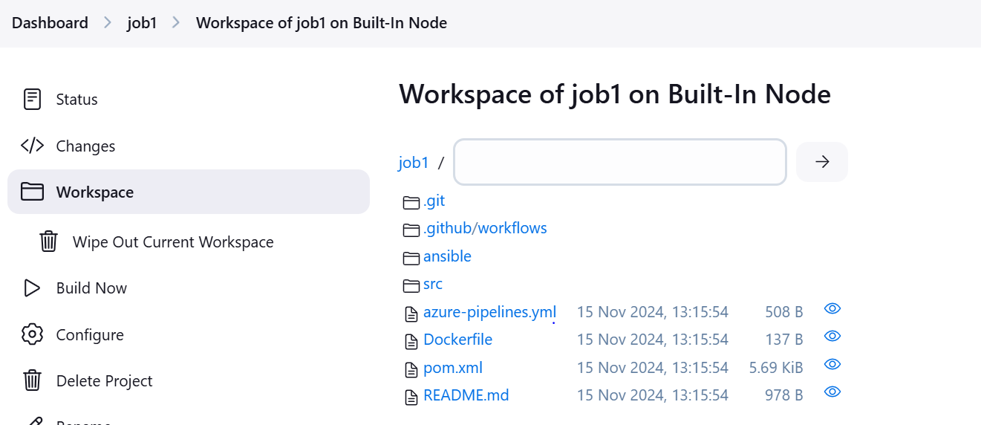

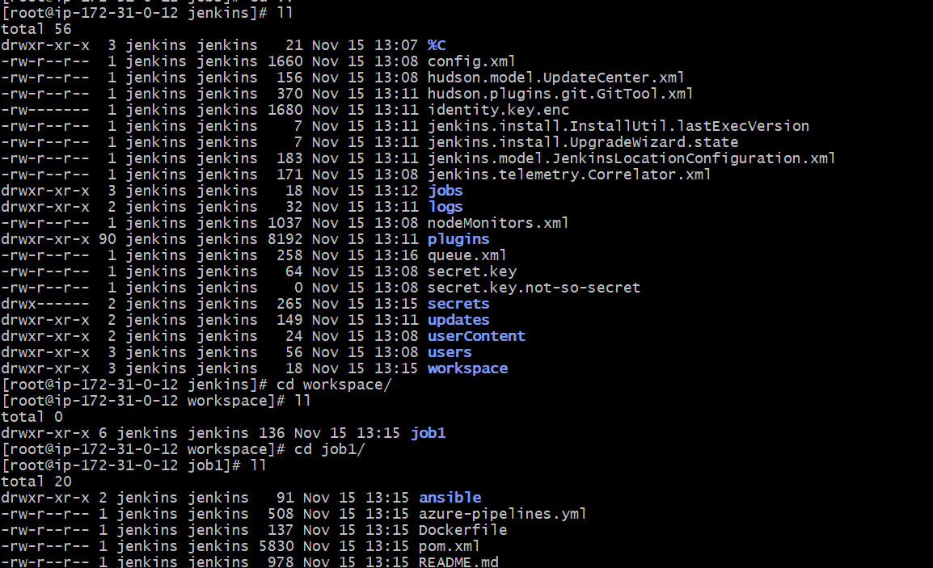

**JOB-2**

**Adding label to the job** 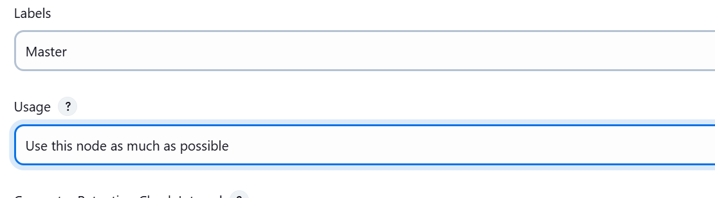

**JOB-3**

**Adding label to the job**

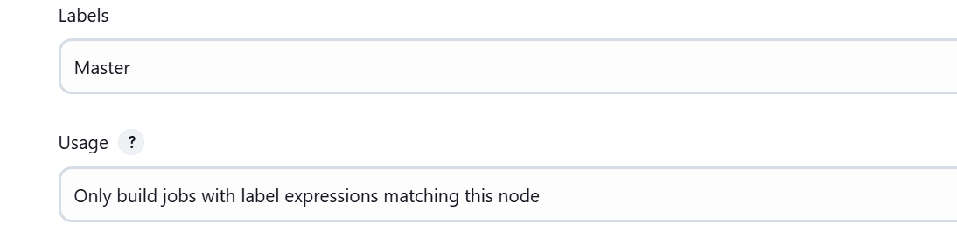

We can check the status of the job

Job2 executed as label was given

Job3 was in queque and will be in queque always

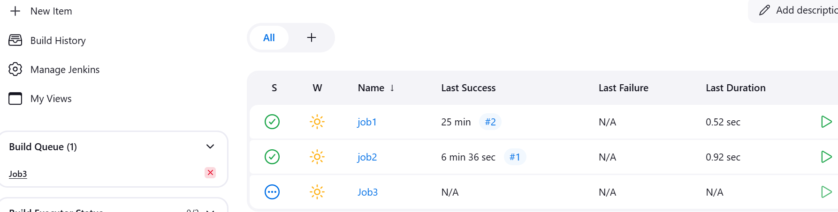

**6) Create one Jenkins job using git hub Private repository**

Create a new job with default settings

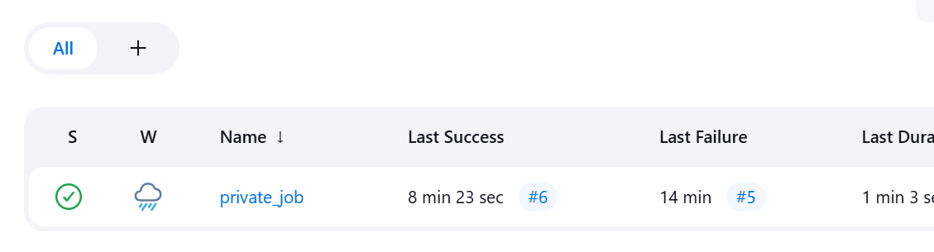

2)created a git repo and added Token access[Repo access]

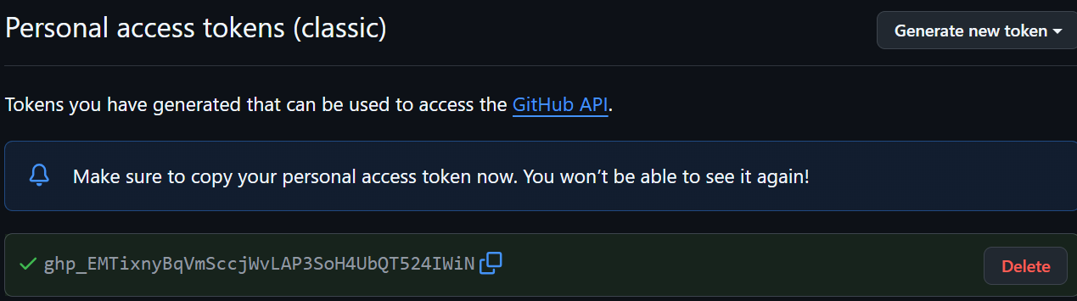

Added credentials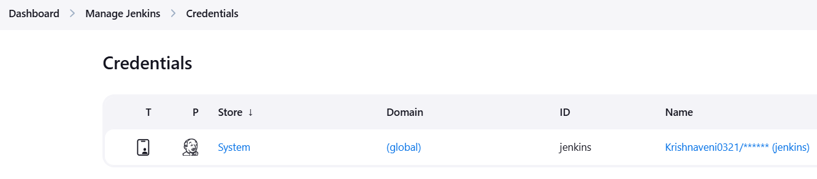

In Id[we need to paste the access key token]

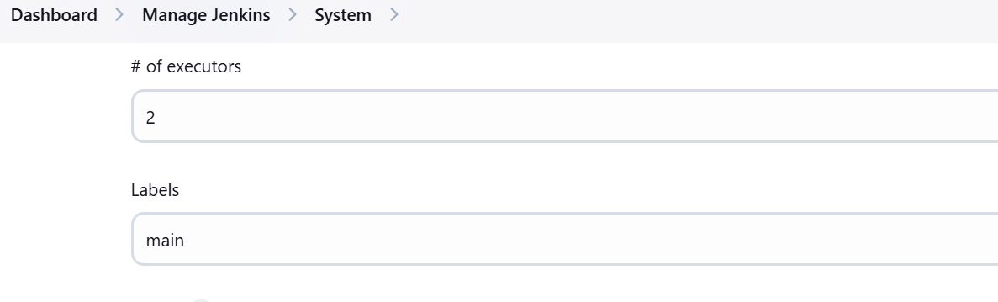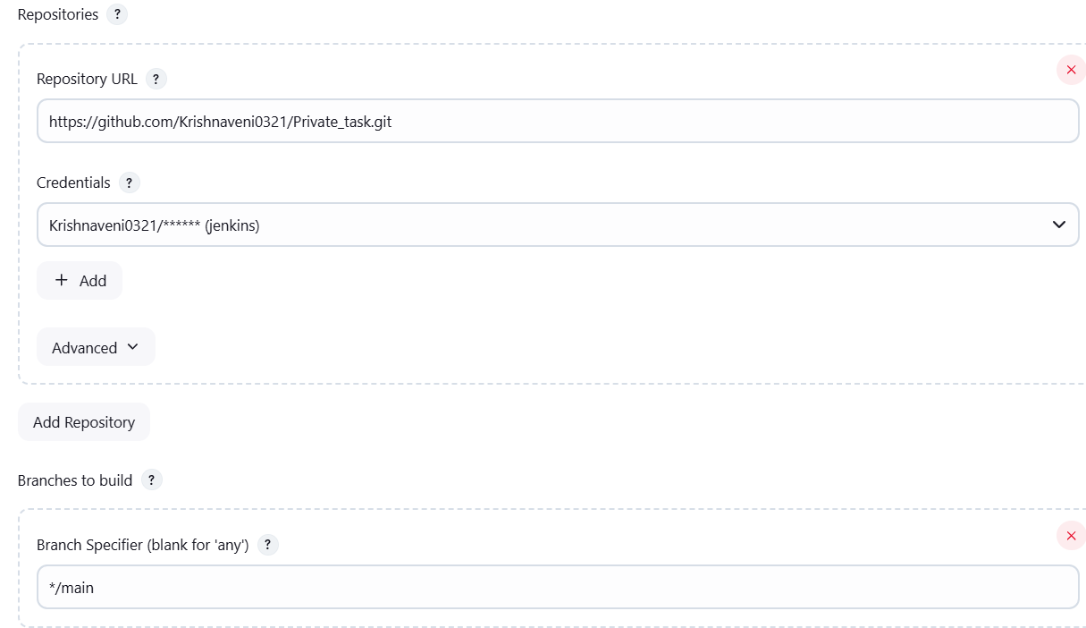

Executing build now 

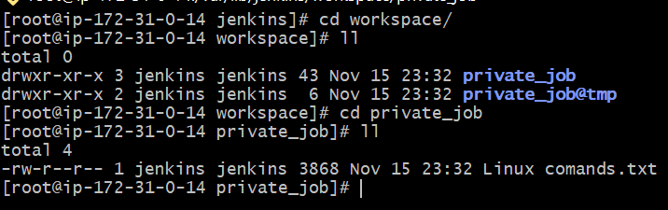

Console output:

